***Task1: Cypress test for a web application:***

*1.Create a Cypress test (loginTest.cy.js) that*

*2. Use the following Cypress features:*

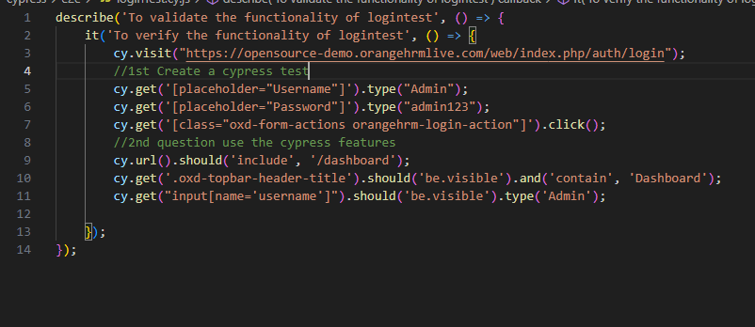

***Task 2 :***

***1st Question :***

***Modify the previous test (loginTest.cy.js) to include:***

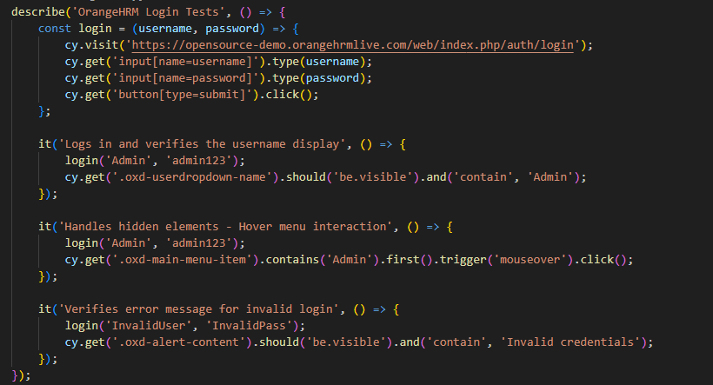

***Task-2***

***2nd Question:\***

*Write a second test (formTest.cy.js) that:*

